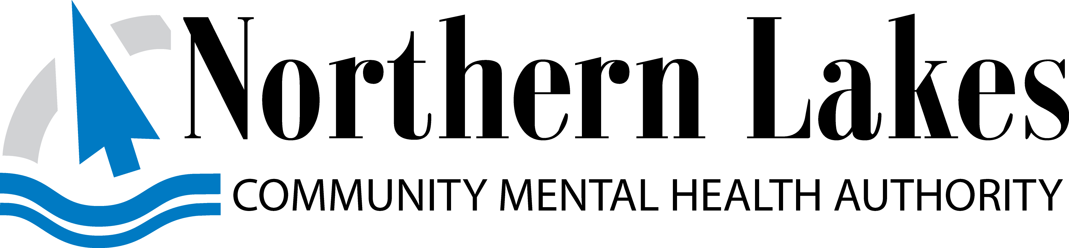
Administrative Office, 105 Hall Street, Suite A,
Traverse City, MI 49684

Northern Lakes Community Mental Health Board of Directors

Special Board Meeting

Agenda

Date & Time: 01/30/2024
Place: 105 Hall Street, Traverse City, MI 49684 – 3rd Floor Board Room

2:00 p.m. Confirmation of a Quorum

2:05 p.m. Public Comment

2:10 p.m. Audit Assessment Findings
- Rehmann Group

4:00 p.m. Adjourn (unless finished sooner)

NOTICE: If any person with a disability needs accommodations, please call the
CEO’s Office three days prior to the posted meeting date.

