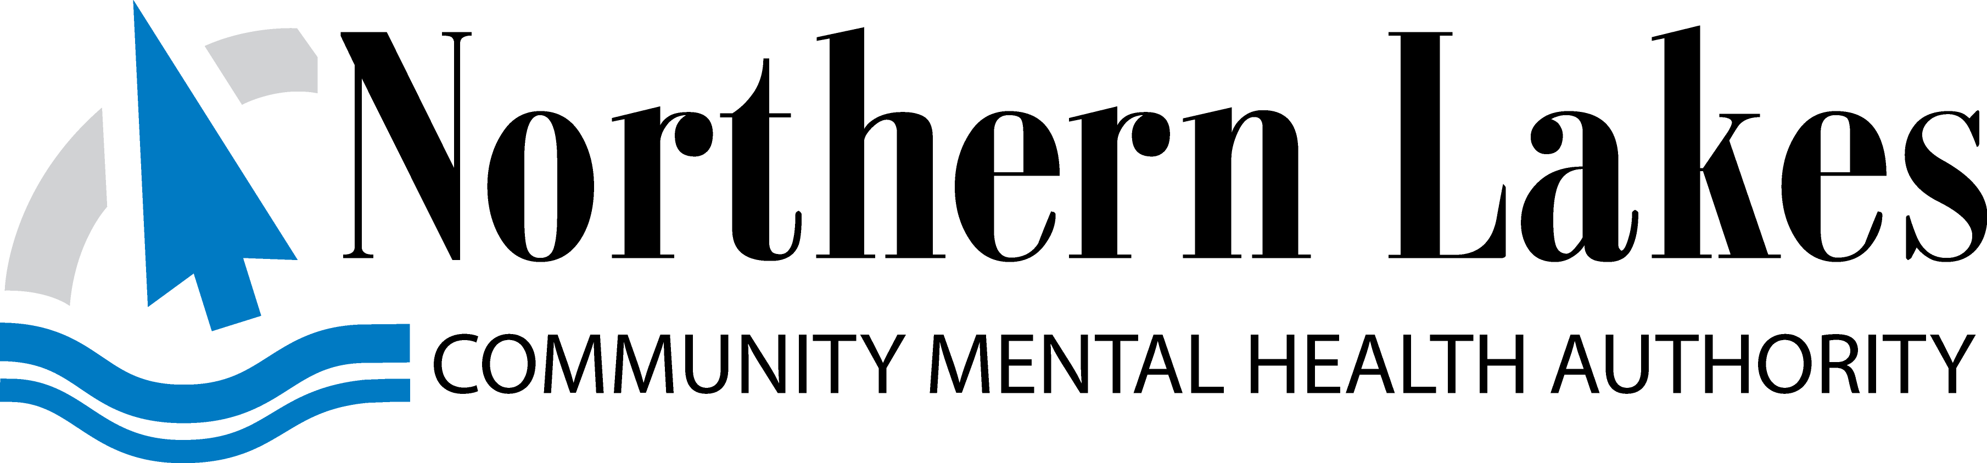
Administrative Office, 105 Hall Street, Suite A,
Traverse City, MI 49684

BOARD AGENDA

The Northern Lakes Community Mental Health Authority Board will meet on September 17, 2020
at 2:15 p.m. Northern Lakes Community Mental Health Authority, 527 Cobb Street, Cadillac;
105 Hall Street, Traverse City; 2715 S. Townline Road, Houghton Lake; and 204 Meadows Drive,
Grayling, (Dial 1-810-258-9588 Conference ID 720 161 70 #)
This line will be available 10 minutes before the meeting starts

On July 17, 2020 Governor Whitmer signed into effect Executive Order 2020-154. In an effort to reduce the spread of COVID-19 by limiting the number of people at public gatherings, this order suspends the rules and procedures for governmental entities requiring physical presence at meetings and hearings and it temporarily alters the rights of the public to be present at meetings.

As permitted by Executive Order 2020-154 and for the reasons stated therein and the current public health concerns posed by gatherings of people, the Northern Lakes CMHA Board of Director’s meeting will be held in person and remotely for the September 17, 2020 meeting along with future Board of Director’s meetings until further notice. We encourage remote participation. Anyone wishing to give public comment will need to call in and wait in a "virtual waiting room" where their microphones will be muted until they are called upon: Dial: 1-810-258-9588 Conference ID 720 161 70 #. This line will be available 10 minutes before the meeting starts. This call will be recorded.

TIME ID # ITEMS POLICY #

2:15 p.m. Roll Call
Pledge of Allegiance
Appoint Timekeeper
Confirmation of Quorum
Consideration of Agenda
Conflict of Interest Declaration

2:20 p.m. Consent Agenda - Board
Consideration of Board Consent Agenda*
1 Board of Directors’ Minutes – August 20, 2020 - Approve
2 Committee of the Whole Minutes – August 20, 2020 – Approve
3 Financial Statements – Receive and File
4 Contract Summary – Approve

2:30 p.m. Ownership Linkage 1.1, 3.1
A. Citizen Comment
(May be limited to five minutes by Board Chairperson)
B. Ownership Communication

2:40 p.m. 5 Chief Executive Officer’s Report

2:55 p.m. 6 Northern Michigan Regional Entity Report 3.4
NMRE Minutes – August 26, 2020

3:05 p.m. Closed Session (Open Meetings Act MCL 15.268 (a)(e))

3:25 p.m. Assurance of Organizational Performance 3.0, 3.2
- Receipt of CEO Monitoring Report
CEO Response to Monitoring Report
7 2.1 Consumer Services (Internal Inspection)*

B. New Operational Worries

C. September Monitoring Assignment -
8 1.0 Consumer and Community Ends 1.0.6-1.0.11 (Internal Inspection)
9 2.3 Compensation of the Employed Workforce (Internal Inspection)

3:35 p.m. Board Means Self-Assessment 3.2, 4.2
- Receipt of Board Monitoring Report
CEO Response to Monitoring Report
10 4.2 Accountability (Direct Inspection)*

B. September Monitoring Assignment
None

3:45 p.m. Governance Policies Discussion and Assessment 3.1
A. Ends
B. Executive Limitations
C. Governance Process/Ownership Linkage
11 - NLD Minutes – September 3, 2020* - Review and Approve
D. Board/CEO Linkage

3:55 p.m. Ownership Linkage 1.1, 3.1
A. Citizen Comment
(May be limited to five minutes by Board Chairperson)

4:00 p.m. Announcements/Board Members Reports/Board Association

4:10 p.m. October 15, 2020 Agenda Planning – Cadillac

4:15 p.m. Meeting Evaluation/Comments

4:20 p.m. Adjournment

NOTICE: If any person with a disability needs accommodations, please call the
CEO’s Office three days prior to the posted meeting date.

NEXT MEETING: October 15, 2020 – Cadillac
* Action Items
** Action from Committee of the Whole
*** Action Other

